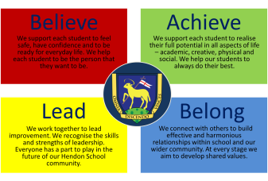
HENDON SCHOOL
Headteacher: Rhona Povey Telephone: 020 8202 9004
Golders Rise, London NW4 2HP Email:info@hendonschool.co.uk
Website: www.hendonschool.co.uk

‘Learning Together Across the World’

Thursday 28 July 2022

Dear Parent/Carer,

With the Summer Holiday upon us, you might be considering replacing some of your child’s uniform, ready for a fresh new start in September. We believe that the wearing of our school uniform helps to build community and a sense of belonging. We maintain and insist upon a high standard of dress for all our students because we recognise that appearance and performance are often directly linked.

From September, students who arrive at school without the correct uniform may be sent home to change. On returning to school, students will then stay behind at the end of the day to complete any missing work. On rare occasions, a student may not be able to wear the correct uniform. When this situation occurs, the student should come to school with a note signed by a parent/carer which clearly outlines the reason and gives a date for when the uniform will be corrected. We have a number of clean, used uniforms in school which students may be asked to wear.

I have attached a copy of our uniform regulations to this letter so that you are aware of what is and isn’t appropriate.

I must stress that we consider Nike’s ‘Airforce’ to be trainers not school shoes and these will not be accepted as appropriate footwear. Please note that any unnatural dyed hair colour is also not acceptable (green, blue, pink etc).

Should you have any queries, please refer to your child’s Head of Year in the first instance or a member of our admin team.

Current Year Group | Head of Year | Email
7 | Phoebe Williams | WilliamsP@hendonschool.co.uk
8 | Garfield Hall | HallG@hendonschool.co.uk
9 | Ticah Fearon | FearonT@hendonschool.co.uk
10 | Gail Jordan | JordanG@hendonschool.co.uk
HS6 | Rick Hollingworth | HollingworthR@hendonschool.co.uk
Admin Team | N/A | Info@hendonschool.co.uk

On behalf of all of the staff at Hendon School, I would like to take this opportunity to wish all of our students and their families a very restful and safe Summer holiday and we look forward to welcoming you back in September.

Yours faithfully

Tamieka Sooknanan
Deputy Headteacher

Uniform Regulations

KS3 and KS4 Students

Navy blue blazer with school badge (mandatory) Navy blue sweatshirt with school badge (optional) Tie
Sensible ‘all black’ shoes (not trainers)
Blue or black plain jacket/coat to be worn over the school blazer (not in place of) Navy blue knee/full length skirt
Black tailored trousers Blue or black tights
Black, navy blue or white socks shorter than knee length
A headscarf worn for religious reasons must be plain white, black or navy

Jewellery

Maximum of two stud earrings which are no bigger than 3mm in diameter One religious necklace worn under the shirt

Additional Guidance

The following items must not be worn on the school site:

Jeans
Tracksuit tops or hoodies
High heels, platform shoes, plimsolls, sliders, trainers (including ‘Airforce’) Coloured scarves, bandanas, hats, caps, durags
Revealing or excessively tight clothing, tight trousers, or skinny jeans Extremes of fashion or personal appearance
Ear stretchers, visible body piercing including nose/lip/face, eyebrow or tongue piercing
Coloured/dyed hair

On rare occasions, a student may not be able to wear the correct uniform. When this situation occurs, the student should arrive to school with a note signed by a parent/carer which clearly outlines the reason and gives a date for when the uniform will be corrected. We have a number of clean, used, uniforms in school that students may be asked to wear.

Students wearing the incorrect uniform may be required to return home to change and/or receive a sanction according to the school behaviour policy.

The decision regarding the suitability of the uniform will be taken by the Head of Year and Senior Leadership Team.

PE Kit – September 2022

Following government guidance means that from September, students are able to access our changing room facilities in PE and Dance. In September, students will therefore need to arrive to school wearing their full school uniform and not their PE or Dance kit.

Students can wear any of the following whilst taking part in their PE/Dance lesson:

- Plain black or navy-blue leggings/tracksuit bottoms
- Blue Hendon shorts
- Red Hendon PE polo top (KS3)
- Black Hendon PE polo top (KS4)
- Purple Hendon PE polo top
- Blue Hendon School PE socks
- Plain black base layers (optional)
- Black Dance t-shirt with gold writing (KS4 Dance only)

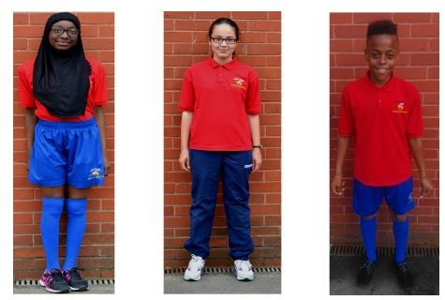

Students should not:

- Wear their PE/Dance kit at any time other than when they are in a PE/Dance lessons

- Wear any other colour leggings/tracksuit bottoms other than plain black OR navy blue in their PE/Dance lessons

- Wear any other T-shirt other than the Hendon School approved polo/dance T- shirts in their PE/Dance lessons

Parents/Carers may be contacted if students do not have the correct PE/Dance kit for their lessons

HS6 dress code

We believe it is important to prepare students for life after school, including understanding the importance of personal presentation at work. The expectation is that all students should attend school appropriately dressed for a working environment. Therefore, the HS6 dress code is the same as the HS staff dress code.

Acceptable dress will include:

- Tailored trousers, smart chinos, skirt or dress. Skirts and dresses should be of a suitable length. Leggings may be worn with a longer top or with a skirt. ‘Jeggings’ are not allowed.

- Blouse, shirt, tailored top or t shirts without large/ offensive slogans.

- Jumpers or cardigans and smart sweatshirts without large/ offensive slogans are acceptable but not ‘hoodies’.

- Smart looking shoes of a type similar to that worn lower down the school, but does not have to be black. Boots are also allowed.

Unacceptable dress will include:

- T shirts with offensive slogans

- Jeans, shorts or combats

- Trainers, converse style canvas shoes, flip-flops

- Hoodies, including ‘leavers’ hoodies

- Trousers hanging down at the back

- Revealing clothing – (leggings or similar items must be worn with a minimum mid-thigh length top) tops that expose the abdomen are unacceptable as are strapless, backless or baggy tops with logos.

- Tracksuits / sports gear

- Hats or caps on school premises

